

VBECS Application Interfacing Support Software (VBECS 1.0)
Installation and User Configuration Guide

April 2009

Department of Veterans Affairs
Office of Enterprise Development
This page intentionally left blank.

Revision History
Date | Revision | Description | Author
06-14-06 | 1.0 | Initial release | BBM team
02-23-07 | 2.0 | Reformatted to conform to VA standards, replaced “Blood Bank ADPAC” with “Laboratory ADPAC” throughout, replaced references to the VBECS ADT-A40 ROUTER protocol with the VBECS ADT-A40 CLIENT protocol in Patient Merge Events, deleted references to the VBECS ADT-A40 ROUTER, inserted screen captures and validation for HL7-related component setup included in the BUNDLE, added a glossary. | BBM team
01-29-08 | 3.0 | Added information on scheduling the VAFC BATCH UPDATE option in TaskMan.  Added Computerized Patient Record System (CPRS) Setup Guide to the “Related Manuals and Reference Materials.”  Updated formatting in Figure 6.  Added the VBECS DSS Extract entity to Figure 6.  Removed the VBECS Patient RBCAG entity from Figure 6.  Added informational text to Figure 7 and Figure 8.  Corrected the instructions for “Assign the B Type Option to Blood Bank Users”  Updated the Message Structure data in Figure 12.  Updated step 2 in Create an HL7 Monitor View for VBECS.  Added instructions to start the “OERR-VBECS” logical link, the “VBECSPTM” logical link, the “VBECSPTU” logical link to “Start VistA HL7 Logical Links.” (steps 3, 5, and 6)  Added instructions to restart the link if necessary to step 8 of “Start VistA HL7 Logical Links.”  Added “Fully Qualified Domain Name” to the Glossary.  Added information on using the Fully Qualified Domain Name to Hardware Information in Appendix B.  Addressed items in 052 VistA MR 082107  Updated the required patches in Required Patches (figure 3).  Added notices that the examples listed and the individual site responses may not be identical to the sites display.  Clarified the description of the people that can add users to a mail group.  Updated the HL/7 examples.  Updated the Routine Checksums.  Updated the Bundle Installation Example. | BBM team
02-14-08 | 4.0 | Removed references to OR*3*212  Replaced the capture in Appendix A with a capture from V7 T1  Added additional information on the required population of the data in Appendix B to a new item 1 on page 8 | BBM team
01-16-09 | 5.0 | Updated guide to address comments from Clinical Product Support (CPS) review:  Revised Cover Page display.  Updated checksums and patch list in Figure 2.  Updated the required builds list in Figure 3.  Updated screen captures in Figures 10 through 26.  Changed references to VBECS TRIGGER to VBECS ADT in Activate HL7 Components and Monitoring Processes on pages 15 through 32.  Corrected ROUTING LOGIC entries in the VBECS ADT-A08 ROUTER protocol in Patient Update Events pages 17 through 23.  Added instructions to add the XOBV VISTALINK TESTER option to the secondary menu of anyone given access to the VBECS Administrator to Appendix B.  Added instructions to populate the “LAB COLLECTION SAMPLE” field (File #60, Field #9) in the new tests listed in Figure 8 where appropriate to the note preceding Figure 8.  Added instructions to change the TYPE field (File $60, Field #3) to OUTPUT (CAN BE DISPLAYED) for all pre-existing Blood Bank tests to the note preceding Figure 8.  Corrected capture for the VBECS ADT-A40 Client receiving application.  Added Order Update Events section.  Corrected link to Appendix B.  Reworded step 6 and step 11 of Set Up VBECS Outbound Logical Links. | BBM team
04-24-09 | 6.0 | Updated guide to address comments from Clinical Product Support (CPS) review:  Install and Configure VBECS BUNDLE 1.0, Installation Procedure: old steps #16 and #17 were updated, moved, and inserted, after step #8.  Appendix B: Updated the table in Hardware Information with the VA assigned port numbers.  Introduction: Reworded the second paragraph of the Overview to differentiate the new namespaces in VistA.  Set Up the VBECS Inbound Logical Link, reworded step #6.  Installation Procedures, step #8: changed response to Yes.  Installation Procedures, step #1 and #4: added notes. | BBM team

Table of Contents

Revision History i
Table of Contents iii
Introduction 1
Overview 1
Namespace 2
File Range 2
Routine Checksums 3
Globals 4
Estimated Time for Installing VBECS BUNDLE 1.0 4
Required Patches 4
Related Manuals and Reference Materials 5
Install and Configure VBECS BUNDLE 1.0 7
Installation Procedures 7
Post-Installation Routine 8
Assign the B Type Option to Blood Bank Users 12
Set Up the VBECS INTERFACE ADMIN Mail Group 13
Assign Security Keys to Blood Bank Users 13
Activate HL7 Components and Monitoring Processes 15
Set Up VBECS Protocol Definitions 16
Patient Update Events 17
Patient Merge Events 24
Order Update Events 27
Order Update Events Continued 30
Create an HL7 Monitor View for VBECS 33
Set Up VBECS Outbound Logical Links 35
Set Up the VBECS Inbound Logical Link 37
Start VistA HL7 Logical Links 38
Monitor VBECS HL7 Logical Links 38
Schedule “VAFC BATCH UPDATE” in TaskMan 40
Validate Post-Installation Configuration 43
Validate the Topography Field File 43
Validate the Collection Sample File 43
Validate the Laboratory Test File 43
Set Up Test Account for HL7 Messaging 45
Glossary 47
Appendices 49
Appendix A: Example of VBECS BUNDLE 1.0 Installation 49
Appendix B: Configuration Worksheet 57
Appendix C: Installation Checklist 61
Index 63

Introduction

Overview
The re-engineered Blood Bank system facilitates ongoing compliance with Food and Drug Administration (FDA) standards for medical devices and also enhances the Department of Veterans Affairs (VA) Veterans Health Administration’s (VHA) ability to deliver quality services to meet the needs of the user community. The system is considered an encapsulated medical device and, therefore, does not communicate directly with other VistA applications. This document describes the installation and configuration procedures required that allow VBECS and VistA applications to communicate with each other. Install this software in a test account and validate it with the re-engineered Blood Bank medical device software prior to installing it in a production account.
The release of VBECS 1.0 introduces two namespaces to the VistA enterprise that support application interfacing between the Blood Bank medical device and VistA applications; “gov.va.med.vbecs” represents the Windows server based Blood Bank medical device software, and “VBEC” represents the VistA based VBECS Application Interfacing Support software. The “VBEC” namespace is installed in the VistA PACKAGE file (#9.4) during the installation of the VBECS BUNDLE 1.0 KIDS multi-package installation. Refer to the diagram in Figure 1 for an overview of the application interfacing between the two new namespaces.
The VBECS BUNDLE 1.0 KIDS multi-package installation uses the VA “Kernel Installation and Distribution System” (KIDS) utility to install all routines, globals, and FileMan data dictionary references associated with the VBECS namespace. This build is distributed as a host file during the phased implementation of the re-engineered Blood Bank system. The VBECS 1.0 build included in the host file contains software and data dictionaries that support HL7 Interfacing, VistALink Remote Procedures, Blood Bank APIs, Computerized Patient Record System (CPRS) Order Entry support, and Lab workload reporting that support the Blood Bank medical device. Prior to installing the VBECS BUNDLE 1.0 KIDS build, ensure that the required patches are installed on the VistA system.
These KIDS builds will be installed as part of the VBECS BUNDLE 1.0 multi-package installation:
- VBECS 1.0
- LR*5.2*325
Refer to Appendix A: Example of VBECS BUNDLE 1.0 Installation for an example of a typical VBECS BUNDLE 1.0 KIDS installation.
Figure 1: VBECS Application Interfacing Schema
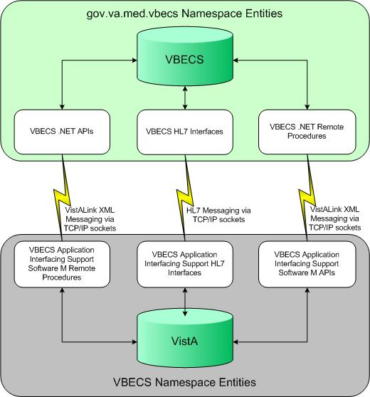

Namespace
The namespace of the VBECS Application Interfacing Support package is “VBEC.” It is installed with the VBECS 1.0 build.

File Range
The VBECS file range is 6000–6009.

Routine Checksums
All routine checksums listed in Figure 2 were collected using the new CHECK1^XTSUMBLD utility.
Note: The VBECA1, VBECA1A, VBECA3A, VBECA3B, VBECA4, and VBECA5A routines were released through Lab Services patches LR*5.2*288 and LR*5.2*294 under the VBECS child namespace. With the release of VBECS 1.0, the VBECS namespace is no longer a child of Lab Services and these routines no longer indicate the patch list associated with the LR namespace.
Figure 2: VBECS 1.0 and LR*5.2*325 Routine Checksums
VBECS 1.0
Checksum Checksum
Routine Before Install After Install Patch List
------- -------------- ------------- ----------
VBECA1 42809195 15238106 N/A
VBECA1A 3879109 4232079 N/A
VBECA1B N/A 61255311 N/A
VBECA1B1 N/A 35331122 N/A
VBECA3 N/A 13958816 N/A
VBECA3A 9998377 116577 N/A
VBECA3B 10238360 10836564 N/A
VBECA3C N/A 16841971 N/A
VBECA4 9746447 15334551 N/A
VBECA5A 1674894 2902941 N/A
VBECA5B N/A 8762794 N/A
VBECA6 N/A 10870720 N/A
VBECA7 N/A 28140649 N/A
VBECA7A N/A 37404950 N/A
VBECA7A1 N/A 69945388 N/A
VBECA7B N/A 64114607 N/A
VBECENV N/A 11886954 N/A
VBECHLRT N/A 3440546 N/A
VBECLU N/A 62085514 N/A
VBECLU0 N/A 22984698 N/A
VBECLU3 N/A 17629716 N/A
VBECPOST N/A 81343398 N/A
VBECRL N/A 10917646 N/A
VBECRPC N/A 37044839 N/A
VBECRPC1 N/A 5917800 N/A
VBECRPCA N/A 73291905 N/A
VBECRPCB N/A 37262884 N/A
VBECRPCC N/A 23397469 N/A
VBECRPCD N/A 4946296 N/A
VBECRPCE N/A 8061175 N/A
VBECRPCH N/A 4049349 N/A
VBECRPCM N/A 41078175 N/A
VBECRPCP N/A 17844001 N/A
VBECRPCW N/A 4711802 N/A
VBECVLC N/A 21445006 N/A

LR*5.2*325
Checksum Checksum
Routine Before Install After Install Patch List
------- -------------- ------------- ----------
LR325 18317711 325
LRCAPBB 22393368 24523132 72,201,325
LRCAPBV 50416998 325
LRCAPBV1 5105874 325

Globals
The ^VBEC(6002.01 global represents the “VBECS WORKLOAD CAPTURE” file.
This file holds Blood Bank workload-related entries while Lab processes them and reports them to national and local workload recording applications. When entries are successfully recorded, VBECS updates the status of the record and deletes the entries from this file.
Although the growth of this file may vary by site, it is not expected to grow more than 1.49 megabytes per day.

Estimated Time for Installing VBECS BUNDLE 1.0
Depending on the hardware installed at each site, the VBECS BUNDLE 1.0 installation process may take less than five minutes.

Required Patches
Figure 3 lists the patches required for installing VBECS BUNDLE 1.0.
Figure 3: Required Patches
Required Applications | Minimum Version Number | Required Patches
DSS | 3.0 | ECX*3.0*102
FileMan | 22.0 | DI*22*159
HL7 | 1.6 | N/A
Kernel | 8.0 | XU*8*399
Laboratory Services | 5.2 | LR*5.2*288, LR*5.2*294, LR*5.2*387, LR*5.2*367, LR*5.2*335
CPRS | 27 | OR*3.0*243
Surgery | 3.0 | SR*3.0*168
ToolKit | 7.3 | XT*7.3*106,XT*7.3*116
VistALink | 1.5 | N/A

Related Manuals and Reference Materials

- Computerized Patient Record System (CPRS) Setup Guide
- KERNEL SYSTEMS MANUAL Version 8.0
- VA ELECTRONIC MAIL SYSTEM (MAILMAN) TECHNICAL MANUAL AND SYSTEMS MANAGEMENT GUIDE Version 7.1
- VistA Blood Establishment Computer Software (VBECS )1.4.0.0 Installation Guide
This page intentionally left blank.

Install and Configure VBECS BUNDLE 1.0

Installation Procedures
Do not install the VBECS BUNDLE 1.0 build until the Implementation Manager instructs you to do so. Install this software in a test account and validate it with the re-engineered Blood Bank medical device software prior to installing it in a production account.
- Complete the information requested in Appendix B: Configuration Worksheet. Do not proceed beyond this step until the data has been entered, validated, and a copy has been sent to the Implementation Manager.
Note: Patch installer must enter the collection sample types for new Lab tests created during installation. Obtain the sample types from the Laboratory Information Manager.
- Obtain the “VBECS_BUNDLE_1.KID” file in accordance with the Implementation Manager’s instructions.
- Use the “LOAD A DISTRIBUTION” option on the “KIDS INSTALLATION” menu. Enter VBECS_BUNDLE_1.KID.
- Select Installation menu from the “Kernel Installation & Distribution System” menu.
Note: Patch installation requires responses from the installer and must not be queued.
- You may use these options (at the “INSTALL NAME” prompt, enter VBECS BUNDLE 1.0):
- “Backup a Transport Global” will create a backup message of routines exported with the patch. It will not back up changes such as DDs and templates.
- “Compare Transport Global to Current System” allows you to view changes made when the patch is installed. It compares components of the patch (e.g., routines, DDs, templates).
- “Verify Checksums in Transport Global” allows you to ensure the integrity of the routines in the transport global.
- “Print Transport Global” allows you to view the components of the KIDS build.
- In the “Install Package(s)” option, select VBECS BUNDLE 1.0.
- At the “Enter the Coordinator for Mail Group ‘VBECS INTERFACE ADMIN’” prompt, enter the name of the individual responsible for maintaining the VBECS package and interfaces [typically the Automated Data Processing Application Coordinator (ADPAC) responsible for the Blood Bank]. This mail group receives notifications when an HL7 transmission or query through the VBECS VistALink client to the Blood Bank medical device fails. Add individual users to this mail group after the installation of the VBECS BUNDLE 1.0 build.
- If the “Want KIDS to Rebuild Menu Trees Upon Completion of Install?” prompt appears, enter Yes.
- At the “VBECS Server IP Address” prompt, enter the Cluster IP address of the Blood Bank medical device cluster server listed in Appendix B: Configuration Worksheet, Hardware Information, row 1.
- At the “VBECS VistALink Listener Service Port Number” prompt, enter the “VistALink Listener Service” port number on the Blood Bank medical device cluster server listed in Appendix B: Configuration Worksheet, Hardware Information, row 2 for installing in the TEST account, row 3 for installing in the PRODUCTION account.
- If the “Want KIDS to INHIBIT LOGONs during the install?” prompt appears, it is recommended that you enter No.
- If the “Want to DISABLE Scheduled Options, Menu Options, and Protocols?” prompt appears, enter No.
- At the “Select COLLECTION SAMPLE for Lab Test ABO/RH – LAB” prompt, select the appropriate collection sample.
- At the “Select COLLECTION SAMPLE for Lab Test ANTIBODY SCREEN - LAB” prompt, select the appropriate collection sample.
- At the “Select COLLECTION SAMPLE for Lab Test DIRECT ANTIGLOBULIN TEST - LAB prompt”, select the appropriate collection sample.
- At the “Select COLLECTION SAMPLE for Lab Test TRANSFUSION REACTION WORKUP - LAB” prompt, select the appropriate collection sample.
- At the “Select COLLECTION SAMPLE for Lab Test TYPE & SCREEN - LAB” prompt, select the appropriate collection sample.
- The VBECPOST post-installation routine will be deleted from your system automatically after successful installation.

Post-Installation Routine
The post-installation routine for the VBECS 1.0 KIDS build will create entries (if they do not exist) in VistA files used by the software to support the Blood Bank medical device.
The post-installation routine assigns values to certain fields based on data identified at each site, therefore, some of the fields associated with these entries will not match at all sites.
See Figure 4–Figure 8 for examples.
Figure 4: TOPOGRAPHY FIELD File (#61)
TOPOGRAPHY FIELD File (#61)
NAME: OTHER SNOMED CODE: OTHER
Figure 5: COLLECTION SAMPLE File (#62)
COLLECTION SAMPLE File (#62)
NAME: VBECS - NO SPECIMEN REQUIRED DEFAULT SPECIMEN: OTHER
LAB SECTION: BLOOD BANK CAN LAB COLLECT: NO
SYNONYM: NRQ
ACCESSION AREA: BLOOD BANK
Figure 6: PARAMETERS File (#8989.5)
PARAMETERS File (#8989.5)
ENTITY: VBECS PARAMETER: VBECS VISTALINK
INSTANCE: LISTENER IP ADDRESS VALUE: 10.3.21.12
ENTITY: VBECS PARAMETER: VBECS VISTALINK
INSTANCE: LISTENER PORT NUMBER VALUE: 19821
ENTITY: VBECS PARAMETER: VBECS VISTALINK
INSTANCE: VBECS Order Entry VALUE: #%hHke).jk)eKP>#zR{!
ENTITY: VBECS PARAMETER: VBECS VISTALINK
INSTANCE: VBECS Workload VALUE: &nKJN-+l5N+-QU][\bH/
ENTITY: VBECS PARAMETER: VBECS VISTALINK
INSTANCE: VBECS Update Workload Event
VALUE: )WVu%m"M`%"mKB2Zek<-
ENTITY: VBECS PARAMETER: VBECS VISTALINK
INSTANCE: VBECS Patient ABO_RH VALUE: 2tr}2z~\Q2~z'G4&Xjw
ENTITY: VBECS PARAMETER: VBECS VISTALINK
INSTANCE: VBECS Patient TRRX VALUE: *91TE6\)RE\6<UA#md{$
ENTITY: VBECS PARAMETER: VBECS VISTALINK
INSTANCE: VBECS Patient ABID VALUE: +}]D<`~-+<~`=:d#*)H/
ENTITY: VBECS PARAMETER: VBECS VISTALINK
INSTANCE: VBECS DSS Extract VALUE: *B-8f"LK`fL"2[]Op?Y
ENTITY: VBECS PARAMETER: VBECS VISTALINK
INSTANCE: VBECS Patient Available Units
VALUE: 0y{(7lb$-7bl?epC0)'-
ENTITY: VBECS PARAMETER: VBECS VISTALINK
INSTANCE: VBECS Blood Products VALUE: .?uK{;A"I{A;G=H_*-(%
ENTITY: VBECS PARAMETER: VBECS VISTALINK
INSTANCE: VBECS Patient Transfusion History
VALUE: '&{e#}I[F#I}0 ziOL<2
ENTITY: VBECS PARAMETER: VBECS VISTALINK
INSTANCE: VBECS Patient Report VALUE: ,.Nab3HC"bH34E|M#ZD1
Figure 7: BLOOD INVENTORY File (#65)

The VBECS1 Blood Product must be configured for your site. The appropriate DIVISION must be inserted using the “EDIT UNIT LOG-IN” (LRBLSEL) option.

BLOOD INVENTORY File (#65)
UNIT ID: VBECS1 SOURCE: VBECS SYSTEM
INVOICE#: 1.0 COMPONENT: VBECS PRODUCT
DATE/TIME RECEIVED: DEC 05, 2005@08:43:13
EXPIRATION DATE/TIME: JAN 01, 2010 ABO GROUP: N/A
RH TYPE: N/A DIVISION: VA HEARTLAND - WEST, VISN 15
DISPOSITION DATE: DEC 05, 2005@08:43:13
Figure 8: LABORATORY TEST File (#60)

The Laboratory tests added must be configured for your site. The appropriate INSTITUTION and ACCESSION AREA must be added using the “Edit cosmic tests” (LRDIECOSMIC) option. The TYPE field in Existing Blood Bank tests should be set to OUTPUT to prevent these tests from being ordered after VBECS has been installed.
Any of the diagnostic tests that will be ordered for Lab Collect (LC) must also have a LAB COLLECTION SAMPLE defined in addition to the COLLECTION SAMPLE. The LAB COLLECTION SAMPLE can be edited with the EDIT COSMIC TESTS (LRDIECOSMIC) option.

LABORATORY TEST File (#60)
NAME: ABO/RH - LAB TYPE: OUTPUT (CAN BE DISPLAYED)
SUBSCRIPT: BLOOD BANK UNIQUE COLLECTION SAMPLE: YES
HIGHEST URGENCY ALLOWED: STAT PRINT NAME: ABO RH
COLLECTION SAMPLE: BLOOD
INSTITUTION: VA HEARTLAND - WEST, VISN 15
ACCESSION AREA: BLOOD BANK
INSTITUTION: COLUMBIA, MO VAMC ACCESSION AREA: COBLOOD BANK
INSTITUTION: LEAVENWORTH VAMC ACCESSION AREA: LEBLOOD BANK
INSTITUTION: TOPEKA, KS VAMC ACCESSION AREA: TOBLOOD BANK
INSTITUTION: WICHITA VAMC ACCESSION AREA: WIBLOOD BANK
NAME: ANTIBODY SCREEN - LAB TYPE: OUTPUT (CAN BE DISPLAYED)
SUBSCRIPT: BLOOD BANK UNIQUE COLLECTION SAMPLE: YES
HIGHEST URGENCY ALLOWED: STAT PRINT NAME: AB SCRN
COLLECTION SAMPLE: BLOOD
INSTITUTION: VA HEARTLAND - WEST, VISN 15
ACCESSION AREA: BLOOD BANK
INSTITUTION: COLUMBIA, MO VAMC ACCESSION AREA: COBLOOD BANK
INSTITUTION: LEAVENWORTH VAMC ACCESSION AREA: LEBLOOD BANK
INSTITUTION: TOPEKA, KS VAMC ACCESSION AREA: TOBLOOD BANK
INSTITUTION: WICHITA VAMC ACCESSION AREA: WIBLOOD BANK
NAME: CRYOPRECIPITATE - LAB TYPE: OUTPUT (CAN BE DISPLAYED)
SUBSCRIPT: BLOOD BANK UNIQUE COLLECTION SAMPLE: YES
HIGHEST URGENCY ALLOWED: STAT PRINT NAME: CRYOPRE
COLLECTION SAMPLE: VBECS - NO SPECIMEN REQUIRED
INSTITUTION: VA HEARTLAND - WEST, VISN 15
ACCESSION AREA: BLOOD BANK
INSTITUTION: COLUMBIA, MO VAMC ACCESSION AREA: COBLOOD BANK
INSTITUTION: LEAVENWORTH VAMC ACCESSION AREA: LEBLOOD BANK
INSTITUTION: TOPEKA, KS VAMC ACCESSION AREA: TOBLOOD BANK
INSTITUTION: WICHITA VAMC ACCESSION AREA: WIBLOOD BANK
NAME: DIRECT ANTIGLOBULIN TEST - LAB TYPE: OUTPUT (CAN BE DISPLAYED)
SUBSCRIPT: BLOOD BANK UNIQUE COLLECTION SAMPLE: YES
HIGHEST URGENCY ALLOWED: STAT PRINT NAME: DAT
COLLECTION SAMPLE: BLOOD
INSTITUTION: VA HEARTLAND - WEST, VISN 15
ACCESSION AREA: BLOOD BANK
INSTITUTION: COLUMBIA, MO VAMC ACCESSION AREA: COBLOOD BANK
INSTITUTION: LEAVENWORTH VAMC ACCESSION AREA: LEBLOOD BANK
INSTITUTION: TOPEKA, KS VAMC ACCESSION AREA: TOBLOOD BANK
INSTITUTION: WICHITA VAMC ACCESSION AREA: WIBLOOD BANK
NAME: FRESH FROZEN PLASMA - LAB TYPE: OUTPUT (CAN BE DISPLAYED)
SUBSCRIPT: BLOOD BANK UNIQUE COLLECTION SAMPLE: YES
HIGHEST URGENCY ALLOWED: STAT PRINT NAME: FFP
COLLECTION SAMPLE: VBECS - NO SPECIMEN REQUIRED
INSTITUTION: VA HEARTLAND - WEST, VISN 15
ACCESSION AREA: BLOOD BANK
INSTITUTION: COLUMBIA, MO VAMC ACCESSION AREA: COBLOOD BANK
INSTITUTION: LEAVENWORTH VAMC ACCESSION AREA: LEBLOOD BANK
INSTITUTION: TOPEKA, KS VAMC ACCESSION AREA: TOBLOOD BANK
INSTITUTION: WICHITA VAMC ACCESSION AREA: WIBLOOD BANK
NAME: OTHER - LAB TYPE: OUTPUT (CAN BE DISPLAYED)
SUBSCRIPT: BLOOD BANK UNIQUE COLLECTION SAMPLE: YES
HIGHEST URGENCY ALLOWED: STAT PRINT NAME: VBOTHER
COLLECTION SAMPLE: VBECS - NO SPECIMEN REQUIRED
INSTITUTION: VA HEARTLAND - WEST, VISN 15
ACCESSION AREA: BLOOD BANK
INSTITUTION: COLUMBIA, MO VAMC ACCESSION AREA: COBLOOD BANK
INSTITUTION: LEAVENWORTH VAMC ACCESSION AREA: LEBLOOD BANK
INSTITUTION: TOPEKA, KS VAMC ACCESSION AREA: TOBLOOD BANK
INSTITUTION: WICHITA VAMC ACCESSION AREA: WIBLOOD BANK
NAME: PLATELETS - LAB TYPE: OUTPUT (CAN BE DISPLAYED)
SUBSCRIPT: BLOOD BANK UNIQUE COLLECTION SAMPLE: YES
HIGHEST URGENCY ALLOWED: STAT PRINT NAME: PLTLTS
COLLECTION SAMPLE: VBECS - NO SPECIMEN REQUIRED
INSTITUTION: VA HEARTLAND - WEST, VISN 15
ACCESSION AREA: BLOOD BANK
INSTITUTION: COLUMBIA, MO VAMC ACCESSION AREA: COBLOOD BANK
INSTITUTION: LEAVENWORTH VAMC ACCESSION AREA: LEBLOOD BANK
INSTITUTION: TOPEKA, KS VAMC ACCESSION AREA: TOBLOOD BANK
INSTITUTION: WICHITA VAMC ACCESSION AREA: WIBLOOD BANK
NAME: RED BLOOD CELLS - LAB TYPE: OUTPUT (CAN BE DISPLAYED)
SUBSCRIPT: BLOOD BANK UNIQUE COLLECTION SAMPLE: YES
HIGHEST URGENCY ALLOWED: STAT PRINT NAME: RED BLD
COLLECTION SAMPLE: VBECS - NO SPECIMEN REQUIRED
INSTITUTION: VA HEARTLAND - WEST, VISN 15
ACCESSION AREA: BLOOD BANK
INSTITUTION: COLUMBIA, MO VAMC ACCESSION AREA: COBLOOD BANK
INSTITUTION: LEAVENWORTH VAMC ACCESSION AREA: LEBLOOD BANK
INSTITUTION: TOPEKA, KS VAMC ACCESSION AREA: TOBLOOD BANK
INSTITUTION: WICHITA VAMC ACCESSION AREA: WIBLOOD BANK
NAME: TRANSFUSION REACTION WORKUP - LAB
TYPE: OUTPUT (CAN BE DISPLAYED) SUBSCRIPT: BLOOD BANK
UNIQUE COLLECTION SAMPLE: YES HIGHEST URGENCY ALLOWED: STAT
PRINT NAME: TRW
COLLECTION SAMPLE: BLOOD
INSTITUTION: VA HEARTLAND - WEST, VISN 15
ACCESSION AREA: BLOOD BANK
INSTITUTION: COLUMBIA, MO VAMC ACCESSION AREA: COBLOOD BANK
INSTITUTION: LEAVENWORTH VAMC ACCESSION AREA: LEBLOOD BANK
INSTITUTION: TOPEKA, KS VAMC ACCESSION AREA: TOBLOOD BANK
INSTITUTION: WICHITA VAMC ACCESSION AREA: WIBLOOD BANK
NAME: TYPE & SCREEN - LAB TYPE: OUTPUT (CAN BE DISPLAYED)
SUBSCRIPT: BLOOD BANK UNIQUE COLLECTION SAMPLE: YES
HIGHEST URGENCY ALLOWED: STAT PRINT NAME: T&S
COLLECTION SAMPLE: BLOOD
INSTITUTION: VA HEARTLAND - WEST, VISN 15
ACCESSION AREA: BLOOD BANK
INSTITUTION: COLUMBIA, MO VAMC ACCESSION AREA: COBLOOD BANK
INSTITUTION: LEAVENWORTH VAMC ACCESSION AREA: LEBLOOD BANK
INSTITUTION: TOPEKA, KS VAMC ACCESSION AREA: TOBLOOD BANK
INSTITUTION: WICHITA VAMC ACCESSION AREA: WIBLOOD BANK
NAME: WHOLE BLOOD - LAB TYPE: OUTPUT (CAN BE DISPLAYED)
SUBSCRIPT: BLOOD BANK UNIQUE COLLECTION SAMPLE: YES
HIGHEST URGENCY ALLOWED: STAT PRINT NAME: WB
COLLECTION SAMPLE: VBECS - NO SPECIMEN REQUIRED
INSTITUTION: VA HEARTLAND - WEST, VISN 15
ACCESSION AREA: BLOOD BANK
INSTITUTION: COLUMBIA, MO VAMC ACCESSION AREA: COBLOOD BANK
INSTITUTION: LEAVENWORTH VAMC ACCESSION AREA: LEBLOOD BANK
INSTITUTION: TOPEKA, KS VAMC ACCESSION AREA: TOBLOOD BANK
INSTITUTION: WICHITA VAMC ACCESSION AREA: WIBLOOD BANK

Assign the B Type Option to Blood Bank Users
The VBECS BUNDLE 1.0 KIDS build installed one new (B)roker Type menu option in the OPTION file (#19). VistALink uses the VBECS VISTALINK CONTEXT option to provide user context sign-on security to VistA. All users of the Blood Bank medical device software must be assigned the VBECS VISTALINK CONTEXT option as a secondary option. Refer to the KERNEL SYSTEMS MANUAL Version 8.0 for more information on assigning secondary options to users.

Set Up the VBECS INTERFACE ADMIN Mail Group
VBECS VistA software will route all alerts generated by VBECS software to the VBECS INTERFACE ADMIN mail group. The VBECS HL7 interfaces and M APIs use this mail group to send notifications when problems arise related to communications between VistA and the Blood Bank medical device. After the mail group is created, the Mail Group Coordinator for the VBECS INTERFACE ADMIN mail group can add users to the group. Users can add themselves to the group. See Figure 9.
Refer to Section 8 (Mail Groups) of the VistA MailMan User GUIDE Version 8.0 for information concerning adding members to this mail group to support VBECS application interfacing.
Figure 9: VBECS INTERFACE ADMIN Mail Group Screen Capture
NAME: VBECS INTERFACE ADMIN TYPE: public
ALLOW SELF ENROLLMENT?: YES
DESCRIPTION: THIS MAIL GROUP IS USED TO RECEIVE ALERT/ERROR MESSAGES FROM
VBECS HL7 INTERFACES AND VISTALINK ISSUES.

Assign Security Keys to Blood Bank Users
The Laboratory ADPAC or Information Resource Management (IRM) must confirm that the LRBLSUPER and/or LRBLOODBANK security keys were assigned to all Blood Bank users in the “NEW PERSON” file (#200).
This page intentionally left blank.

Communication between the VBECS Application Interfacing Support software and the Blood Bank medical device will occur only when the steps in the Activate HL7 Components and Monitoring Processes, Set Up CPRS Order Menu, and Validate Post-Installation Configuration sections are completed.

Activate HL7 Components and Monitoring Processes
Four HL7 Application Parameters, nine Protocols, and four Logical Links (new components) are distributed with the VBECS BUNDLE 1.0 build as part of the VBECS Application Interfacing Support software.
These sections describe the setup requirements for these components.

Set Up VBECS Protocol Definitions
- From the “HL7 Main” Menu, select Interface Developer Options.
- Select Protocol Edit.
Figure 10: HL7 Protocol Menu Navigation
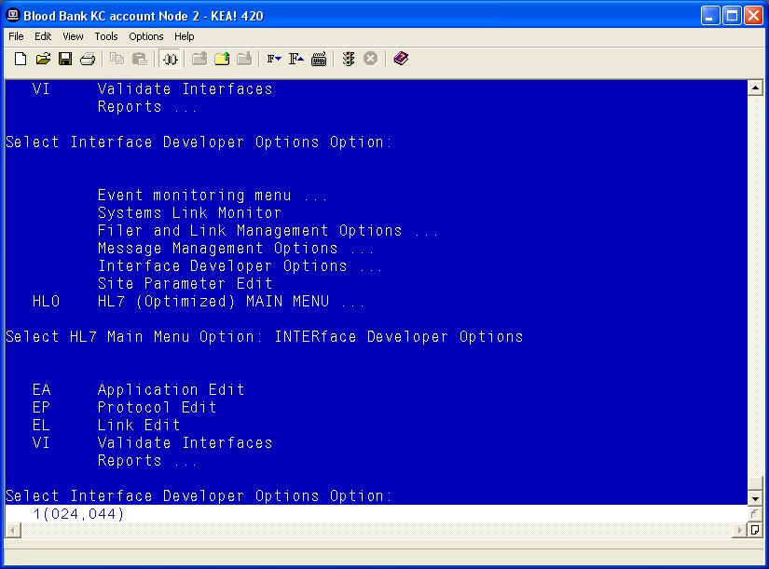

Patient Update Events

Edit VAFC ADT-A08 SERVER Protocol
- Select Edit Protocol and enter VAFC ADT-A08 SERVER.
- Move the cursor to the “TYPE” field and press Enter.
Figure 11: HL7 Interface Setup
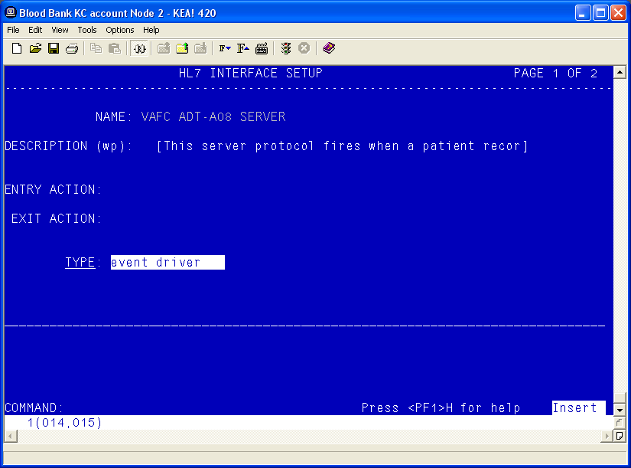
- Move the cursor to below the last entry in the “SUBSCRIBERS” section.
- Enter VBECS ADT-A08 ROUTER and press Enter.
Figure 12: HL7 Event Driver
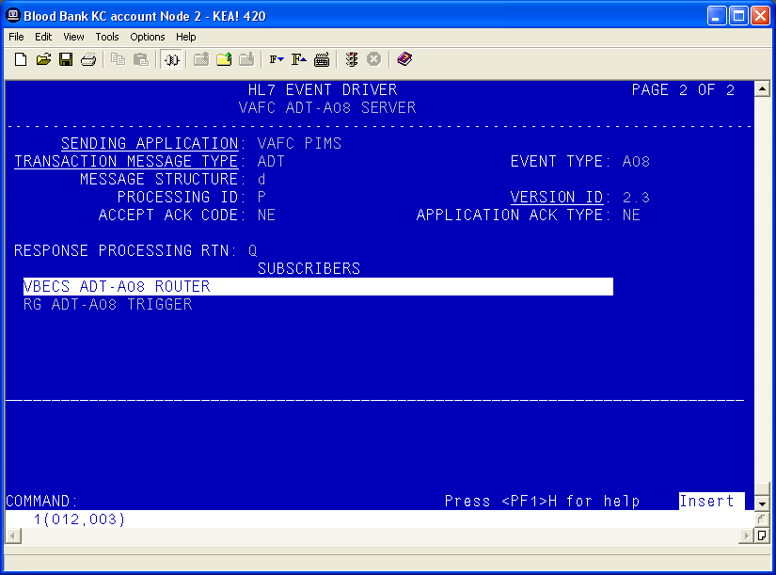
- Accept the default settings in the sub-window.
- Move the cursor to the “RECEIVING APPLICATION” prompt and verify that the entry is “VBECS ADT”.
- Press Enter.
Figure 13: HL7 Subscriber: VBECS ADT-A08 Router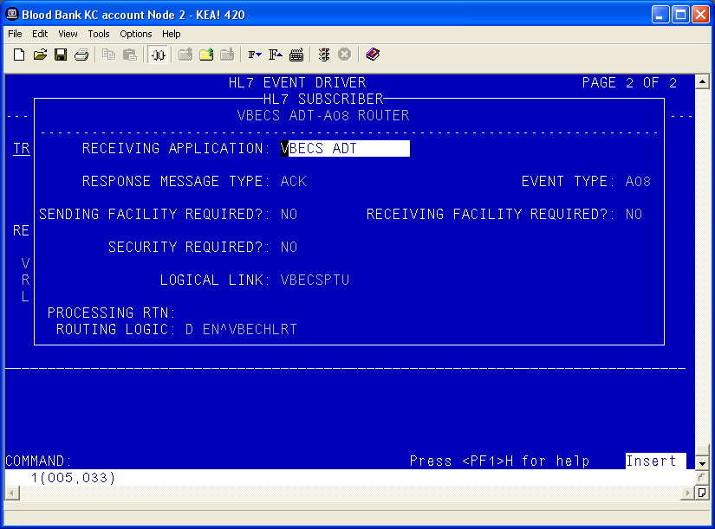
- Move the cursor to the “FACILITY NAME” prompt and enter the station number of the primary division of the site.
- Move the cursor to the “COMMAND” prompt.
- Enter Close and press Enter.
Figure 14: HL7 Subscriber: VBECS ADT-A08 Router
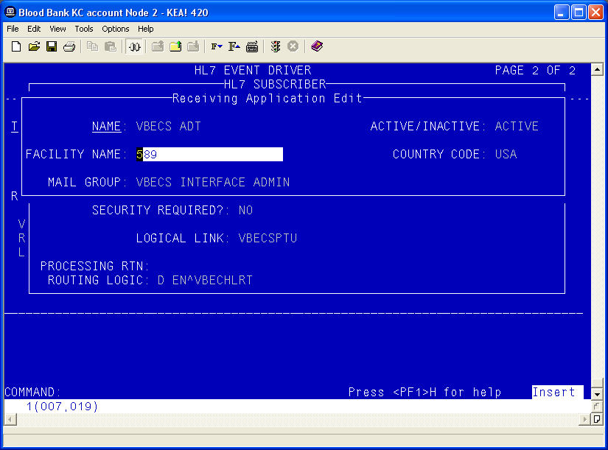
- You will return to the previous screen (Figure 14). Move the cursor to the “COMMAND” prompt.
- Enter Save and press Enter.
- Enter Exit and press Enter.

VBECS ADT-A08 CLIENT
- Select VBECS ADT-A08 CLIENT.
- Move the cursor to the “TYPE” field and press Enter.
Figure 15: HL7 Interface Setup
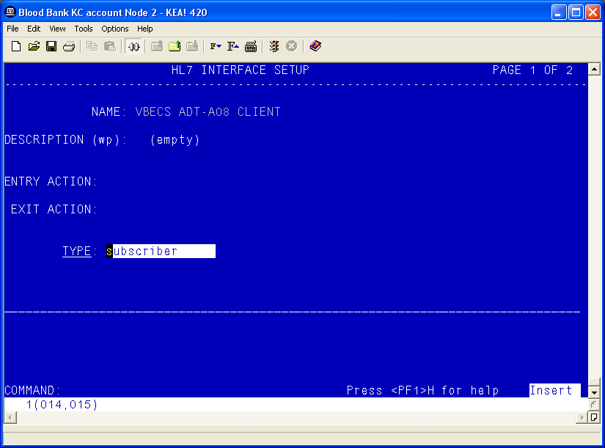
- Move the cursor to the “RECEIVING APPLICATION” prompt and verify that the entry is “VBECS ADT”.
- Press Enter.
Figure 16: HL7 Subscriber: VBECS ADT-A08 Client
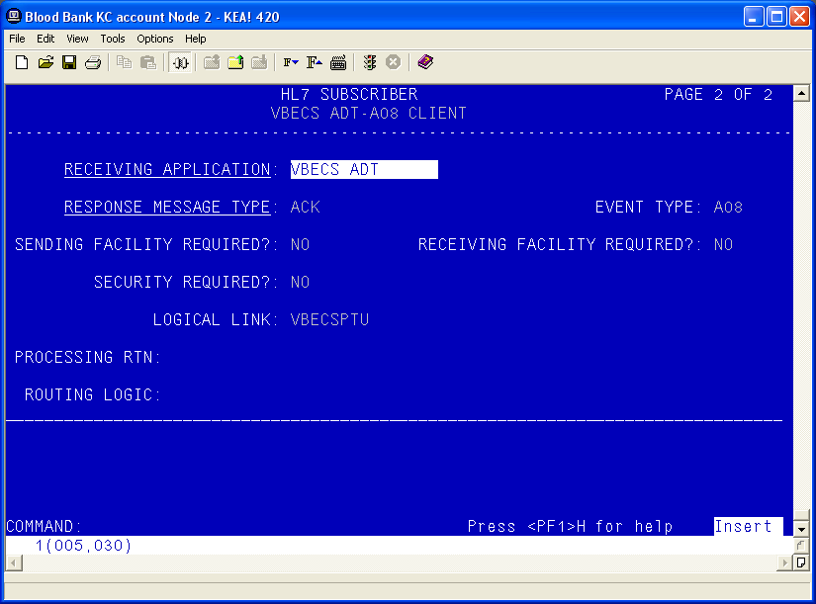
- Move the cursor to the “FACILITY NAME” prompt and enter the station number of the primary division of the site.
- Move the cursor to the “COMMAND” prompt.
- Enter Close and press Enter.
Figure 17: Receiving Application Edit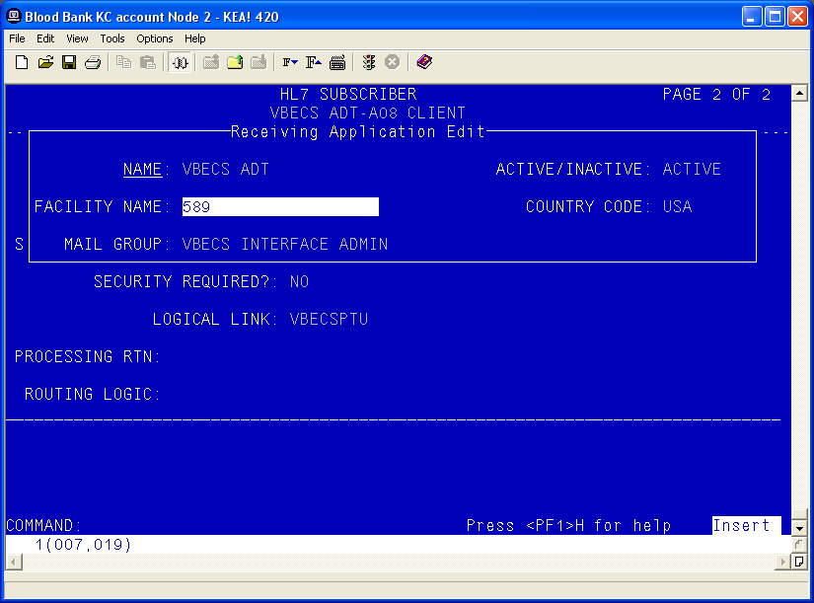
- You will return to the previous screen (Figure 17). Move the cursor to the “COMMAND” prompt.
- Enter Save and press Enter.
- Enter Exit and press Enter.

Patient Merge Events
- Select MPIF ADT-A40 SERVER.
- Move the cursor to the “TYPE” field and press Enter.
Figure 18: HL7 Interface Setup
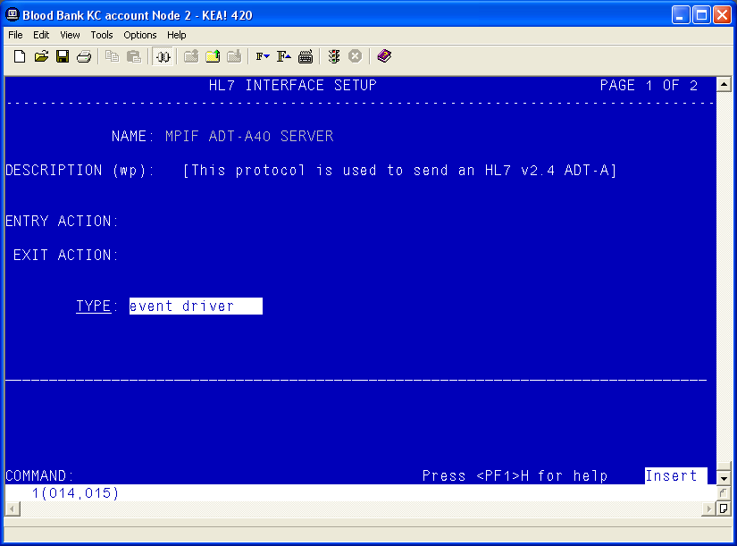
- Move the cursor to below the last entry in the “SUBSCRIBERS” section.
- Enter VBECS ADT-A40 CLIENT and press Enter.
Figure 19: HL7 Event Driver: MPIF ADT-A40 Server
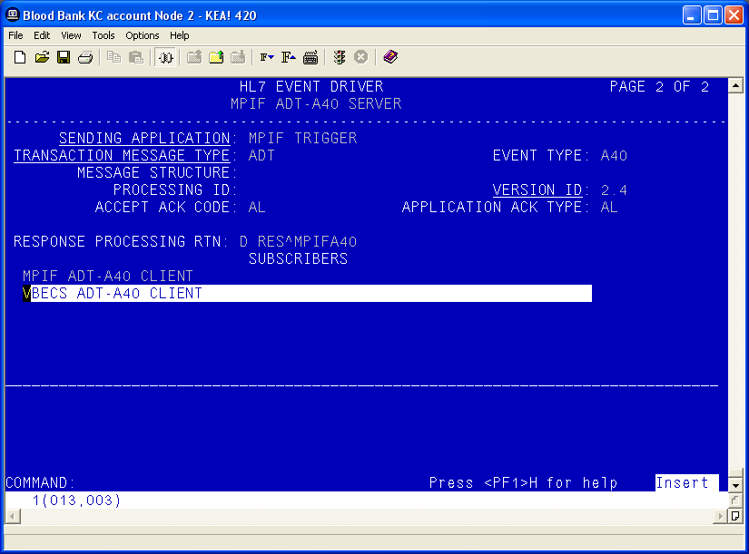
- Accept the default settings in the sub-window.
- Move the cursor to the “COMMAND” prompt.
- Enter Close and press Enter.
- You will return to the previous screen. Move the cursor to the “COMMAND” prompt.
Figure 20: HL7 Subscriber: VBECS ADT-A40 Client
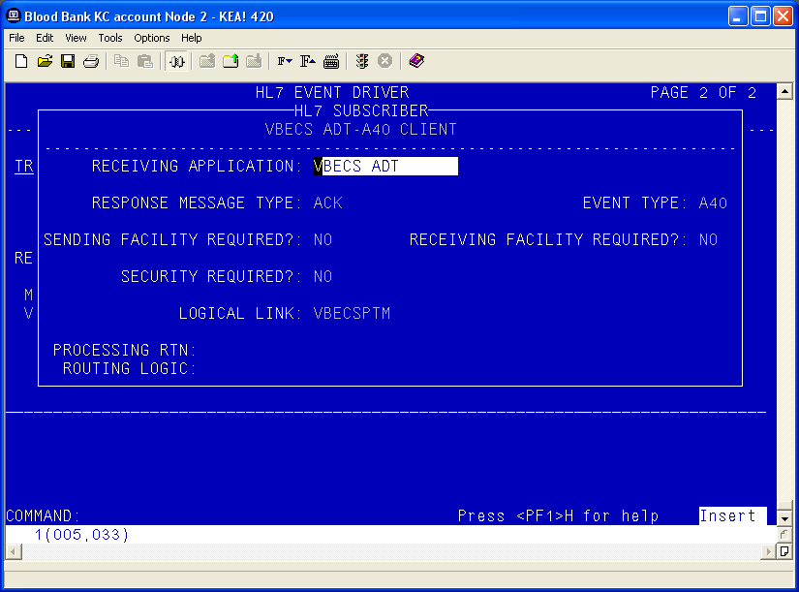
- Enter Save and press Enter.
- Enter Exit and press Enter.

Order Update Events
- Select VBECS OMG SERVER.
- Move the cursor to the “TYPE” field and press Enter.
Figure 21: HL7 Order Update Setup
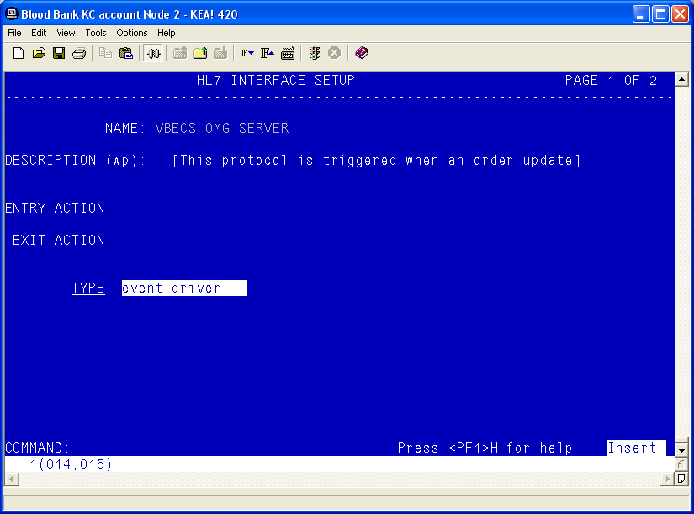
- Move the cursor to below the last entry in the “SUBSCRIBERS” section.
- Enter VBECS OMG CLIENT and press Enter.
Figure 22: HL7 Event Driver: VBECS OMG Server
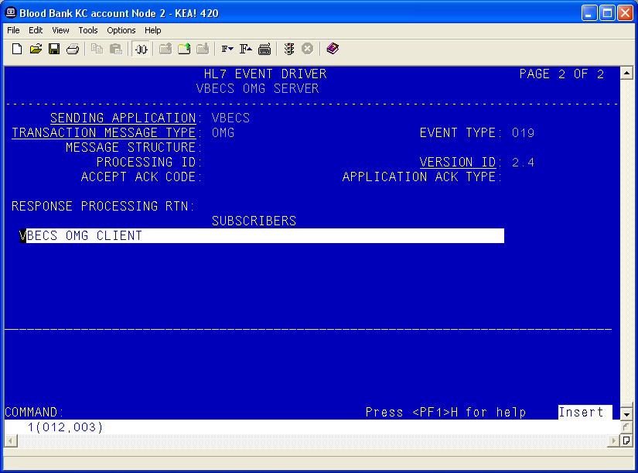
- Verify that the Receiving Application is OERR.
Figure 23: HL7 Event Driver: VBECS OMG Server
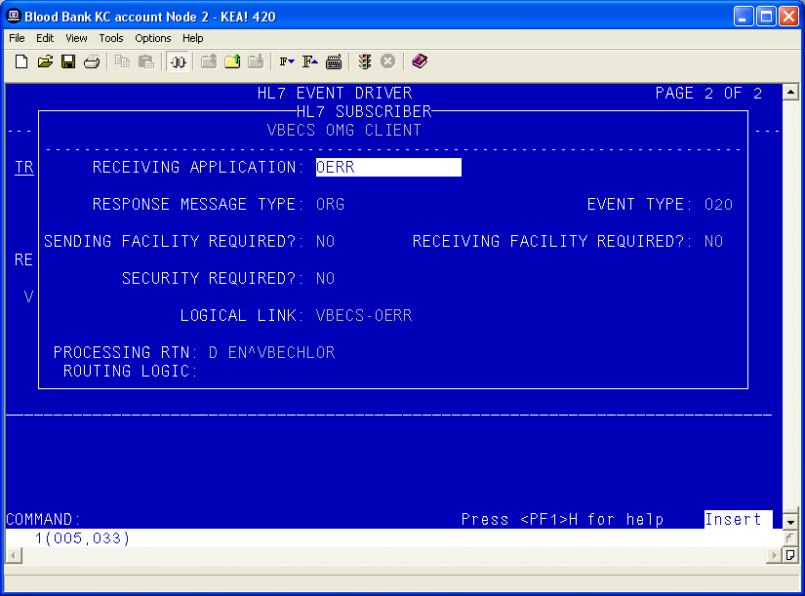
- Move the cursor to the “COMMAND” prompt.
- Enter Close and press Enter.
- Move the cursor to the “COMMAND” prompt.
- Enter Save and press Enter.
- Enter Exit and press Enter.

Order Update Events Continued
- Select VBECS OMG CLIENT.
- Move the cursor to the “TYPE” field and press Enter.
Figure 24: HL7 Interface Setup
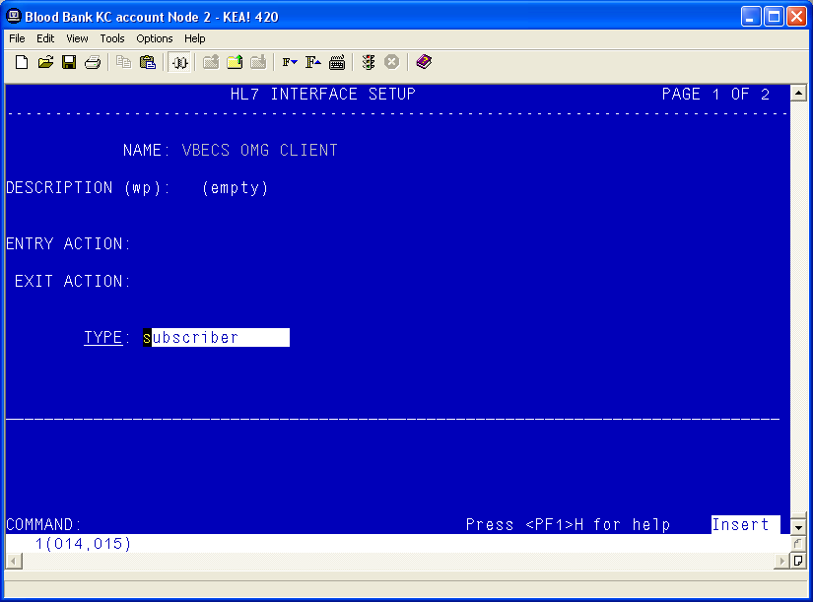
- Verify that the Receiving Application is OERR and press Enter.
Figure 25: HL7 Event Driver: VBECS OMG Client
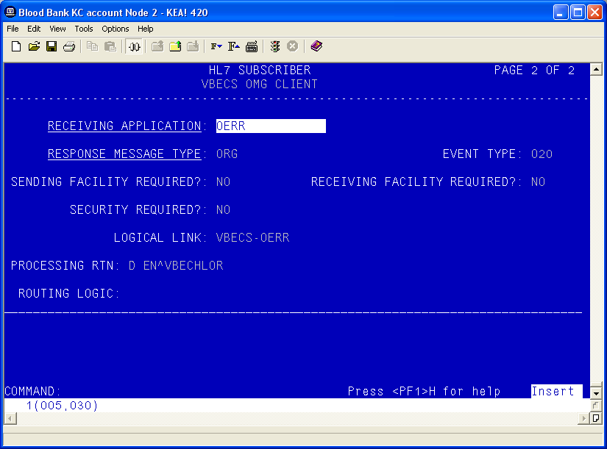
- Enter the correct Facility Name
Figure 26: HL7 Subscriber: VBECS ADT-A40 Client
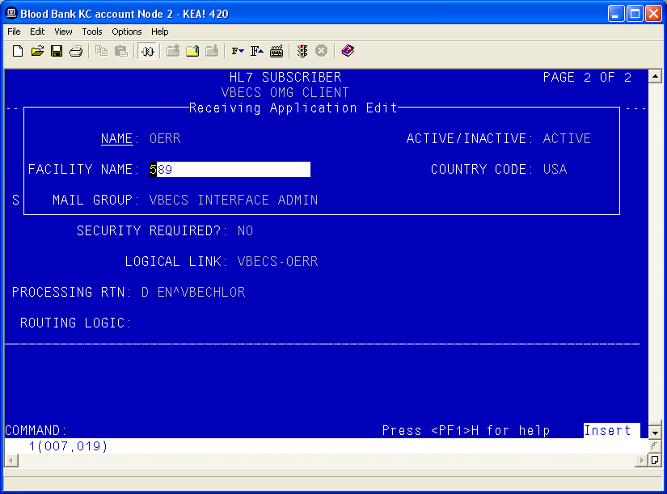
- Move the cursor to the “COMMAND” prompt.
- Enter Close and press Enter.
- Move the cursor to the “COMMAND” prompt.
- Enter Save and press Enter.
- Enter Exit and press Enter.

Create an HL7 Monitor View for VBECS
To better monitor VBECS messaging in the “VistA HL7 System Link Monitor” (menu option “HL MESSAGE MONITOR”), define a new view (“VBECS”).
- From the “HL7 Main” Menu, select Site Parameter Edit.
Figure 27: HL7 Site Parameter Edit Menu Navigation
HL7 Main Menu
Event monitoring menu ...
Systems Link Monitor
Filer and Link Management Options ...
Message Management Options ...
Interface Developer Options ...
Site Parameter Edit

Select HL7 Main Menu Option: Site Parameter Edit
- Move the cursor to the bottom of the System Link Monitor VIEWS to a blank field and enter VBECS.
- At the “Are you adding ‘VBECS’ as a new LINK MONITOR VIEWS?” prompt, enter Y. A new sub-window appears.
Figure 28: Edit HL7 Site Parameters
Edit HL7 Site Parameters Page 1 of 2
-----------------------------------------------------------------------------

Current Domain: <your site information>
Current Institution: <your institution name>
Is this a Production or Test Account? training

Mail Group for Alerts: HL7 TRANS

System Link Monitor VIEWS
-------------------------
VBECS

[Goto next page to edit Background Process Parameters]
------------------------------------------------------------------------------
- In the “LOGICAL LINK” column, enter OERR-VBECS and press Enter.
- In the “DISPLAY ORDER” column, enter 1 and press Enter.
- Repeat these steps for the VBECS-OERR, VBECSPTM, and VBECSPTU links, incrementing the “DISPLAY ORDER” value by 1 for each additional link.
- Press Enter to move the cursor to the “COMMAND” prompt.
- Enter Close to return to the previous screen (Figure 28).
- Move the cursor to the “COMMAND” prompt.
- Enter Save and press Enter.
- Enter Exit and press Enter.
Figure 29: System Link Monitor View
System Link Monitor View
NAME: VBECS

LOGICAL LINK DISPLAY ORDER
------------ -------------
OERR-VBECS 1
VBECS-OERR 2
VBECSPTM 3
VBECSPTU 4

Set Up VBECS Outbound Logical Links
- At the “Select HL7 Main Menu Option” prompt, enter Filer.
- At the “Select Filer and Link Management Options Option” prompt, enter Link Edit.
- At the “Select HL LOGICAL LINK NODE” prompt, enter OERR-VBECS (Figure 30).
Figure 30: HL7 Logical Link Edit Menu Navigation
HL7 Main Menu
Event monitoring menu ...
Systems Link Monitor
Filer and Link Management Options ...
Message Management Options ...
Interface Developer Options ...
Site Parameter Edit

Select HL7 Main Menu Option: FILER

SM Systems Link Monitor
FM Monitor, Start, Stop Filers
LM TCP Link Manager Start/Stop
SA Stop All Messaging Background Processes
RA Restart/Start All Links and Filers
DF Default Filers Startup
SL Start/Stop Links
PI Ping (TCP Only)
ED Link Edit
ER Link Errors ...

Select Filer and Link Management Options Option: ED

Select HL LOGICAL LINK NODE: OERR-VBECS

- Enter Enabled in the “AUTOSTART” field.
- Move the cursor to the “LLP TYPE” field and press Enter.
Figure 31: HL7 Logical Link
HL7 LOGICAL LINK
-----------------------------------------------------------------------------
NODE: OERR-VBECS
INSTITUTION:
DOMAIN:
AUTOSTART: ENABLED
QUEUE SIZE: 10
LLP TYPE: TCP
______________________________________________________________________________
COMMAND: Press <PF1>H for help Insert
- Change the value of the “TCP/IP ADDRESS” and “TCP/IP PORT” parameters to the Internet Protocol (IP) address and port number of the Blood Bank medical device cluster server at your site. Refer to row 1 of Appendix B: Configuration Worksheet for the IP address and to row 4 of Appendix B: Configuration Worksheet for the Test Account Port Number and to row 5 of Appendix B: Configuration Worksheet for the Production Account Port Number.
- Move the cursor to the “COMMAND” prompt.
- Enter Close to return to the previous screen.
- At the “COMMAND:” prompt, enter Save.
- Enter Exit.
Figure 32: TCP Lower Level Parameters: OERR-VBECS
HL7 LOGICAL LINK
-----------------------------------------------------------------------------
TCP LOWER LEVEL PARAMETERS
OERR-VBECS

TCP/IP SERVICE TYPE: CLIENT (SENDER)
TCP/IP ADDRESS: <IP address of Blood Bank cluster server>
TCP/IP PORT: <Port number of Blood Bank cluster server>

ACK TIMEOUT: RE-TRANSMISION ATTEMPTS:
READ TIMEOUT: EXCEED RE-TRANSMIT ACTION: restart
BLOCK SIZE: SAY HELO:

STARTUP NODE: PERSISTENT: NO
RETENTION: 15 UNI-DIRECTIONAL WAIT:
____________________________________________________________________________
COMMAND: Press <PF1>H for help Insert

- Repeat Steps 3 through 10 substituting “VBECSPTM” and “VBECSPTU” for “OERR-VBECS” when prompted for the logical link name to change the IP address and port numbers for the VBECSPTM and VBECSPTU logical links.

Set Up the VBECS Inbound Logical Link
- At the “Select HL7 Main Menu Option” prompt, enter Filer.
- At the “Select Filer and Link Management Options Option” prompt, enter Link Edit.
- At the “Select HL LOGICAL LINK NODE” prompt, enter VBECS-OERR (as shown for OERR-VBECS in figure 30).
- Enter Enabled in the “AUTOSTART” field.
- Move the cursor to the “LLP TYPE” field and press Enter.
Figure 33: HL7 Logical Link
HL7 LOGICAL LINK
-----------------------------------------------------------------------------
NODE: VBECS-OERR
INSTITUTION:
DOMAIN:
AUTOSTART: ENABLED
QUEUE SIZE: 10
LLP TYPE: TCP
_____________________________________________________________________________
COMMAND: Press <PF1>H for help Insert
- No “TCP/IP PORT” should be entered. Change the value of the “TCP/IP PORT” parameter to the port number of the VistA HL7 Listener at your site. Refer to row 10 of Appendix B: Configuration Worksheet for the Test Account Port Number and row 11 of Appendix B: Configuration Worksheet for the Production Account Port Number.
- Move the cursor to the “COMMAND” prompt.
- Enter Close to return to the previous screen.
- At the “COMMAND” prompt, enter Save.
- Enter Exit.
Figure 34: TCP Lower Level Parameters: VBECS-OERR
HL7 LOGICAL LINK
-----------------------------------------------------------------------------
TCP LOWER LEVEL PARAMETERS
VBECS-OERR

TCP/IP SERVICE TYPE: SINGLE LISTENER
TCP/IP ADDRESS:
TCP/IP PORT: <VistA HL7 Listener Port>

ACK TIMEOUT: RE-TRANSMISION ATTEMPTS:
READ TIMEOUT: EXCEED RE-TRANSMIT ACTION:
BLOCK SIZE: SAY HELO:

STARTUP NODE: PERSISTENT: NO
RETENTION: UNI-DIRECTIONAL WAIT:
____________________________________________________________________________
COMMAND: Press <PF1>H for help Insert

Start VistA HL7 Logical Links
- Before data can be transmitted over the VBECS logical links, edit the link definitions as described above.
- To turn on the new VBECS logical links, select Start/Stop Links [HL START].
- Start the “OERR-VBECS” logical link.
- Start the “VBECS-OERR” logical link.
- Start the “VBECSPTM” logical link.
- Start the “VBECSPTU” logical link.
- Ensure that the VistA HL7 Link Manager is running; VBECS messaging cannot occur without it.
- To check the status of the Link Manager (and, if necessary, restart it), access the “HL START/STOP LINK MANAGER” menu option.

Monitor VBECS HL7 Logical Links
Once two-way communication has been established, you can monitor the links.

- Use the “System Link Monitor” to view the status of the VBECS Logical Links.
- From the “HL7 Main” Menu, select System Link Monitor.
Figure 35: HL7 System Link Monitor Menu Navigation
HL7 Main Menu
Event monitoring menu ...
Systems Link Monitor
Filer and Link Management Options ...
Message Management Options ...
Interface Developer Options ...
Site Parameter Edit

Select HL7 Main Menu Option: System Link Monitor

- When a list of VistA HL7 links defined at your site appears, press V at the “Select a Command” prompt.
- At the “Select LINK MONITOR VIEWS” prompt, enter VBECS.
Figure 36: System Link Monitor
SYSTEM LINK MONITOR for <your site name>

MESSAGES MESSAGES MESSAGES MESSAGES DEVICE
NODE RECEIVED PROCESSED TO SEND SENT TYPE STATE

LA7V 657 4 4 MM Halting
LL15VISN 105 105 394 105 NC Shutdown
MPIVA 0 0 322 0 NC Shutdown
NPTF 0 0 25 0 MM Halting
OERR-VBE 34 34 1019 1018 NC Idle
PSOTPBAA 28 28 52 28 NC Shutdown
VABAC 0 0 1 0 NC Shutdown
VAFAV 0 0 2 0 NC Shutdown
VAFHM 0 0 3 0 NC Shutdown
VAFRE 0 0 4 0 NC Shutdown

Incoming filers running => 1 TaskMan running
Outgoing filers running => 1 Link Manager running
Monitor OVERDUE
Select a Command:
(N)EXT (B)ACKUP (A)LL LINKS (S)CREENED (V)IEWS (Q)UIT (?) HELP: V

Select LINK MONITOR VIEWS: VBECS
- A screen similar to Figure 37 appears.
Figure 37: System Link Monitor
SYSTEM LINK MONITOR for <your site name>

MESSAGES MESSAGES MESSAGES MESSAGES DEVICE
NODE RECEIVED PROCESSED TO SEND SENT TYPE STATE

OERR-VBE 0 0 0 0 NC Idle
VBECS-OE 0 0 0 0 SS Idle
VBECSPTM 0 0 0 0 NC Enabled
VBECSPTU 0 0 0 0 NC Enabled

Incoming filers running => 1 TaskMan running
Outgoing filers running => 1 Link Manager Running
Monitor OVERDUE
Select a Command:
(N)EXT (B)ACKUP (A)LL LINKS (S)CREENED (V)IEWS (Q)UIT (?) HELP:
- To exit the “System Link Monitor”, at the “Select a Command” prompt, enter QUIT and press Enter.

The volume of HL7 traffic over these links depends on the number of daily CPRS Blood Bank orders and updates to the VistA clinical information at your site. These can be significant at large sites. Monitor the links closely the first few days after the installation and purge the HL7 log data ( as appropriate) in accordance with your standard HL7 monitoring and purging procedures.

Schedule “VAFC BATCH UPDATE” in TaskMan
When this job is scheduled through TaskMan it will collect and transmit all the entries in the “PIVOT” file that are of an update to patient information. The job will build PIMS A08 HL7 v2.3 messages and broadcast them to any subscriber.

- Select the Schedule/Unschedule Options option from the “TaskMan Management Option” menu.
- Enter VAFC BATCH UPDATE at the “Select OPTION to schedule or reschedule:” prompt.
- You will be prompted to verify that this is the correct option if the option has already been tasked. Enter Y and press Enter.
- You will be prompted to verify that you are adding VAFC BATCH UPDATE as a new scheduled option if the option has not been tasked. Enter Y and press Enter.
- Enter a today’s date and a time 20 minutes in the future at the “QUEUED TO RUN AT WHAT TIME” prompt.
- Enter 600 at the “RESCHEDULING FREQUENCY” prompt.
- Enter STARTUP at the “SPECIAL QUEUEING PROMPT”.
- Enter E at the “COMMAND:” prompt and press Enter.
- Enter Y when asked if you would like to save the changes.

Figure 38: Scheduling a Task
Select Taskman Management Option: schedule/Unschedule Options

Select OPTION to schedule or reschedule: VAFC BATCH UPDATE UPDATE BATCH JOB FOR HL7 v2.3
Are you adding 'VAFC BATCH UPDATE' as
a new OPTION SCHEDULING (the 343RD)? No// Y (Yes)

Figure 39: Entering Task Parameters
Edit Option Schedule
Option Name: VAFC BATCH UPDATE
Menu Text: UPDATE BATCH JOB FOR HL7 v2.3 TASK ID:
__________________________________________________________________________

QUEUED TO RUN AT WHAT TIME: OCT 12,2007@13:30

DEVICE FOR QUEUED JOB OUTPUT:

QUEUED TO RUN ON VOLUME SET:

RESCHEDULING FREQUENCY: 600S

TASK PARAMETERS:

SPECIAL QUEUEING: STARTUP

_______________________________________________________________________________
Exit Save Next Page Refresh

Enter a command or '^' followed by a caption to jump to a specific field.

COMMAND: E

Figure 40: Saving Task Parameters
Edit Option Schedule
Option Name: VAFC BATCH UPDATE
Menu Text: UPDATE BATCH JOB FOR HL7 v2.3 TASK ID:
__________________________________________________________________________

QUEUED TO RUN AT WHAT TIME: OCT 12,2007@13:30

DEVICE FOR QUEUED JOB OUTPUT:

QUEUED TO RUN ON VOLUME SET:

RESCHEDULING FREQUENCY: 600S

TASK PARAMETERS:

SPECIAL QUEUEING:

_______________________________________________________________________________
Exit Save Next Page Refresh

Enter a command or '^' followed by a caption to jump to a specific field.

Save changes before leaving form (Y/N)? Y

This page intentionally left blank.

Validate Post-Installation Configuration

Validate the Topography Field File
The post-installation routine checks whether there is an entry in the TOPOGRAPHY FIELD file (#61) of “OTHER.” If not, one is created. Validate that this entry exists in this file.

Validate the Collection Sample File
The post-installation routine checks whether there is an entry in the “COLLECTION SAMPLE” file (#62) of “VBECS – NO SPECIMEN REQUIRED.” If not, one is created. Validate that this entry exists in this file.

Validate the Laboratory Test File
The post-installation routine creates 11 new entries in the “LABORATORY TEST” file (#60) that are used for specimen collection, when needed, and workload processing. This routine identifies the blood bank accession areas and associated divisions in the VistA system and assigns these values to each of these Lab tests. The component tests listed are assigned the “VBECS – NO SPECIMEN REQUIRED COLLECTION SAMPLE” file (#62) entry. The specimen tests require a specimen collection and must have a valid “COLLECTION SAMPLE” associated with each test. The post-installation routine will prompt the user for a valid “COLLECTION SAMPLE” when creating these tests.
Validate these entries to ensure that the Accession Areas and Divisions assigned are accurate for the tests performed in the associated blood banks.
- Component Tests
- CRYOPRECIPITATE - LAB
- FRESH FROZEN PLASMA - LAB
- OTHER - LAB
- PLATELETS - LAB
- RED BLOOD CELLS - LAB
- WHOLE BLOOD – LAB
- Specimen Tests
- ABO/RH - LAB
- ANTIBODY SCREEN - LAB
- DIRECT ANTIGLOBULIN TEST - LAB
- TRANSFUSION REACTION WORKUP - LAB
- TYPE & SCREEN - LAB

Set Up Test Account for HL7 Messaging
Install and validate the Blood Bank medical device in a VistA test account prior to installing it in the VistA production account. The testing validation procedures require an HL7 interface with CPRS GUI v27, installed with the VBECS BUNDLE 1.0 KIDS build.
VA facilities commonly use the National VistA Support Test Account Reset (NVSTAR) utility to remove HL7 interfacing functionality from test accounts to prevent transmission of HL7 messages. Installing the VBECS BUNDLE 1.0 KIDS build does not re-enable HL7 interfaces that were disabled in a test account. However, using the NVSTAR utility after installing the VBECS BUNDLE 1.0 KIDS build removes the Blood Bank HL7 interfacing functionality and disables communication between VBECS and other VistA applications. If this occurs, refer to Activate HL7 Components and Monitoring Processes to re-enable HL7 interfacing functionality for VBECS.

This page intentionally left blank.

Glossary
Acronym, Term | Definition
ADPAC | Automated Data Processing Application Coordinator.
CPRS | Computerized Patient Record System. A VistA software application that provides an integrated patient record system for use by clinicians, managers, quality assurance staff, and researchers.
FDA | Food and Drug Administration.
FQDN | Fully Qualified Domain Name
gov.va.med.vbecs namespace | Namespace that represents the Blood Bank medical device software.
HL7 | Health Level 7. An international messaging standard used predominantly in the healthcare industry.
IP | Internet Protocol.
IRM | Information Resource Management.
KIDS | Kernel Installation and Distribution System.
M | Formerly “MUMPS” (Massachusetts General Hospital Utility Multi-Programming System).
NVSTAR  RPC Broker | National VistA Support Test Account Reset.  The Remote Procedure Call (RPC) Broker (also referred to as "Broker") is a client/server system within VA's Veterans Health Information Systems and Technology Architecture (VistA) environment. It enables client applications to communicate and exchange data with M Servers.
TCP/IP | Transmission Control Protocol/Internet Protocol.
VA | Department of Veterans Affairs.
VBECS | VistA Blood Establishment Computer Software.
VBEC namespace | Namespace that represents the VBECS Application Interfacing Support M software.
Veterans Health Information Systems and Technology Architecture (VistA) | Formerly the Decentralized Hospital Computer Program (DHCP) of the Veterans Health Administration (VHA), Department of Veterans Affairs (VA). VistA software, developed by the VA, is used to support clinical and administrative functions at VA Medical Centers nationwide. It is written in M and runs on all major M implementations via the Kernel regardless of vendor. VistA is composed of packages that undergo a verification process to ensure conformity with name spacing and other VistA standards and conventions.
VHA | Veterans Health Administration.
VISN | Veterans Integrated Service Network.
VistA | Veterans Health Information Systems and Technology Architecture.
VistALink | A real-time communication link that provides connectivity and utilities for data exchange between VistA and VBECS.

This page intentionally left blank.

Appendices

Appendix A: Example of VBECS BUNDLE 1.0 Installation
Figure 41: Example of VBECS BUNDLE 1.0 Installation. Please note that the answers given to the prompts presented during this capture are not intended to be recommendations for data to be entered during installation. The responses to the prompts presented must be answered with data pertinent to your site.
Select OPTION NAME: XPD MAIN Kernel Installation & Distribution System

Edits and Distribution ...
Utilities ...
Installation ...
Patch Monitor Main Menu ...

<CPM> Select Kernel Installation & Distribution System Option: Installation

1 Load a Distribution
2 Verify Checksums in Transport Global
3 Print Transport Global
4 Compare Transport Global to Current System
5 Backup a Transport Global
6 Install Package(s)
Restart Install of Package(s)
Unload a Distribution

<CPM> Select Installation Option: 1 Load a Distribution
Enter a Host File: C:\KIDS\VBECS_BUNDLE_1.KID

KIDS Distribution saved on Jan 31, 2008@14:43:14
Comment: VBECS BUNDLE 1 Created on 013108@1445

This Distribution contains Transport Globals for the following Package(s):
VBECS BUNDLE 1.0
VBECS 1.0
LR*5.2*325
Distribution OK!

Want to Continue with Load? YES//
Loading Distribution...

VBECS BUNDLE 1.0
Build VBECS 1.0 has an Enviromental Check Routine
Want to RUN the Environment Check Routine? YES//
VBECS 1.0
Will first run the Environment Check Routine, VBECENV

Environment Check beginning...
Checking for required routines...
You have routine XOBVSKT installed.
You have routine XOBUM installed.
Environment check successful. Installation will proceed.

LR*5.2*325
Will first run the Environment Check Routine, LR325

Sending transport global loaded alert to mail group G.LMI
Use INSTALL NAME: VBECS BUNDLE 1.0 to install this Distribution.

1 Load a Distribution
2 Verify Checksums in Transport Global
3 Print Transport Global
4 Compare Transport Global to Current System
5 Backup a Transport Global
6 Install Package(s)
Restart Install of Package(s)
Unload a Distribution

<CPM> Select Installation Option: 6 Install Package(s)
Select INSTALL NAME: VBECS BUNDLE 1.0 Loaded from Distribution 1/31/08@15
:29:36
=> VBECS BUNDLE 1 Created on 013108@1445 ;Created on Jan 31, 2008@14

This Distribution was loaded on Jan 31, 2008@15:29:36 with header of
VBECS BUNDLE 1 Created on 013108@1445 ;Created on Jan 31, 2008@14:43:14
It consisted of the following Install(s):
VBECS BUNDLE 1.0 VBECS 1.0 LR*5.2*325
Checking Install for Package VBECS BUNDLE 1.0

Install Questions for VBECS BUNDLE 1.0

Checking Install for Package VBECS 1.0
Will first run the Environment Check Routine, VBECENV

Environment Check beginning...
Checking for required routines...
You have routine XOBVSKT installed.
You have routine XOBUM installed.
Environment check successful. Installation will proceed.

Install Questions for VBECS 1.0

Incoming Files:

6002.01 VBECS WORKLOAD CAPTURE

Incoming Mail Groups:

Enter the Coordinator for Mail Group 'VBECS INTERFACE ADMIN': (your name here)

Want KIDS to Rebuild Menu Trees Upon Completion of Install? NO// Yes

VBECS Server IP Address: 10.10.10.10
VBECS VistALink Listener Service Port Number: 5001
Checking Install for Package LR*5.2*325
Will first run the Environment Check Routine, LR325

Sending install started alert to mail group G.LMI

--- Environment Check is Ok ---

Install Questions for LR*5.2*325

Want KIDS to INHIBIT LOGONs during the install? NO//
Want to DISABLE Scheduled Options, Menu Options, and Protocols? NO//

Enter the Device you want to print the Install messages.
You can queue the install by enter a 'Q' at the device prompt.
Enter a '^' to abort the install.

DEVICE: HOME// TELNET PORT

Install Started for VBECS BUNDLE 1.0 :
Jan 31, 2008@15:30:04

Build Distribution Date: Jan 31, 2008

Installing Routines

Install Started for VBECS 1.0 :
Jan 31, 2008@15:30:04

Build Distribution Date: Jan 31, 2008

Installing Routines

Jan 31, 2008@15:30:04

Installing PACKAGE COMPONENTS:

Installing MAIL GROUP

Installing HL7 APPLICATION PARAMETER
Located in the VBEC (VBECS) namespace.
Located in the VBEC (VBECS) namespace.
Located in the VBEC (VBECS) namespace.
Located in the VBEC (VBECS) namespace.
Located in the VBEC (VBECS) namespace.
Located in the VBEC (VBECS) namespace.
Located in the VBEC (VBECS) namespace.

Installing REMOTE PROCEDURE

Installing OPTION

Installing PARAMETER DEFINITION

Running Post-Install Routine: EN^VBECPOST

Adding 'OTHER' TOPOGRAPHY FIELD.
'OTHER' TOPOGRAPHY FIELD added successfully.

Adding 'VBECS - NO SPECIMEN REQUIRED' COLLECTION SAMPLE.
'VBECS - NO SPECIMEN REQUIRED' COLLECTION SAMPLE added successfully.

Adding 'VBECS...' LABORATORY TESTS.
---Adding 'ABO/RH - LAB' LABORATORY TEST.
Select COLLECTION SAMPLE for Lab Test ABO/RH - LAB: BLOOD
1 BLOOD BLOOD BACTEC BTL.
2 BLOOD PLASMA GREEN TOP
3 BLOOD TEST-PLASMA NORM NORMAL COAG
4 BLOOD TEST-PLASMA ABNORM ABNORM COAG
5 BLOOD BLOOD RED TOP
Press <RETURN> to see more, '^' to exit this list, OR
CHOOSE 1-5: 5 BLOOD RED TOP
'ABO/RH - LAB' added successfully.
---Adding 'ANTIBODY SCREEN - LAB' LABORATORY TEST.
Select COLLECTION SAMPLE for Lab Test ANTIBODY SCREEN - LAB: BLOOD
1 BLOOD BLOOD BACTEC BTL.
2 BLOOD PLASMA GREEN TOP
3 BLOOD TEST-PLASMA NORM NORMAL COAG
4 BLOOD TEST-PLASMA ABNORM ABNORM COAG
5 BLOOD BLOOD RED TOP
Press <RETURN> to see more, '^' to exit this list, OR
CHOOSE 1-5: 5 BLOOD RED TOP
'ANTIBODY SCREEN - LAB' added successfully.
---Adding 'DIRECT ANTIGLOBULIN TEST - LAB' LABORATORY TEST.
Select COLLECTION SAMPLE for Lab Test DIRECT ANTIGLOBULIN TEST - LAB: BLOOD
1 BLOOD BLOOD BACTEC BTL.
2 BLOOD PLASMA GREEN TOP
3 BLOOD TEST-PLASMA NORM NORMAL COAG
4 BLOOD TEST-PLASMA ABNORM ABNORM COAG
5 BLOOD BLOOD RED TOP
Press <RETURN> to see more, '^' to exit this list, OR
CHOOSE 1-5: 5 BLOOD RED TOP
'DIRECT ANTIGLOBULIN TEST - LAB' added successfully.
---Adding 'TRANSFUSION REACTION WORKUP - LAB' LABORATORY TEST.
Select COLLECTION SAMPLE for Lab Test TRANSFUSION REACTION WORKUP - LAB: BLOOD
1 BLOOD BLOOD BACTEC BTL.
2 BLOOD PLASMA GREEN TOP
3 BLOOD TEST-PLASMA NORM NORMAL COAG
4 BLOOD TEST-PLASMA ABNORM ABNORM COAG
5 BLOOD BLOOD RED TOP
Press <RETURN> to see more, '^' to exit this list, OR
CHOOSE 1-5: 5 BLOOD RED TOP
'TRANSFUSION REACTION WORKUP - LAB' added successfully.
---Adding 'TYPE & SCREEN - LAB' LABORATORY TEST.
Select COLLECTION SAMPLE for Lab Test TYPE & SCREEN - LAB: BLOOD
1 BLOOD BLOOD BACTEC BTL.
2 BLOOD PLASMA GREEN TOP
3 BLOOD TEST-PLASMA NORM NORMAL COAG
4 BLOOD TEST-PLASMA ABNORM ABNORM COAG
5 BLOOD BLOOD RED TOP
Press <RETURN> to see more, '^' to exit this list, OR
CHOOSE 1-5: 5 BLOOD RED TOP
'TYPE & SCREEN - LAB' added successfully.
---Adding 'CRYOPRECIPITATE - LAB' LABORATORY TEST.
'CRYOPRECIPITATE - LAB' added successfully.
---Adding 'FRESH FROZEN PLASMA - LAB' LABORATORY TEST.
'FRESH FROZEN PLASMA - LAB' added successfully.
---Adding 'OTHER - LAB' LABORATORY TEST.
'OTHER - LAB' added successfully.
---Adding 'PLATELETS - LAB' LABORATORY TEST.
'PLATELETS - LAB' added successfully.
---Adding 'RED BLOOD CELLS - LAB' LABORATORY TEST.
'RED BLOOD CELLS - LAB' added successfully.
---Adding 'WHOLE BLOOD - LAB' LABORATORY TEST.
'WHOLE BLOOD - LAB' added successfully.

Adding VBECS VISTALINK PARAMETERS.
---Adding 'VBECS Order Entry' PARAMETER.
'VBECS Order Entry' PARAMETER added successfully.
---Adding 'VBECS Workload' PARAMETER.
'VBECS Workload' PARAMETER added successfully.
---Adding 'VBECS Update Workload Event' PARAMETER.
'VBECS Update Workload Event' PARAMETER added successfully.
---Adding 'VBECS Patient ABO_RH' PARAMETER.
'VBECS Patient ABO_RH' PARAMETER added successfully.
---Adding 'VBECS Patient TRRX' PARAMETER.
'VBECS Patient TRRX' PARAMETER added successfully.
---Adding 'VBECS Patient ABID' PARAMETER.
'VBECS Patient ABID' PARAMETER added successfully.
---Adding 'VBECS Patient Available Units' PARAMETER.
'VBECS Patient Available Units' PARAMETER added successfully.
---Adding 'VBECS Blood Products' PARAMETER.
'VBECS Blood Products' PARAMETER added successfully.
---Adding 'VBECS Patient Transfusion History' PARAMETER.
'VBECS Patient Transfusion History' PARAMETER added successfully.
---Adding 'VBECS Patient Report' PARAMETER.
'VBECS Patient Report' PARAMETER added successfully.
---Adding 'VBECS DSS Extract' PARAMETER.
'VBECS DSS Extract' PARAMETER added successfully.
---Adding 'VISTALINK IP ADDRESS' and 'VISTALINK PORT NUMBER' PARAMETERS.
'VISTALINK IP ADDRESS' and 'VISTALINK PORT NUMBER' PARAMETERS added successfully.

Adding generic VBECS BLOOD INVENTORY
---Adding 'VBECS1' BLOOD INVENTORY.
'VBECS1' BLOOD INVENTORY added successfully.

Updating Routine file...

Updating KIDS files...

VBECS 1.0 Installed.
Jan 31, 2008@15:30:21

Not a production UCI

Not a production UCI

NO Install Message sent
LR*5.2*325

Install Started for LR*5.2*325 :
Jan 31, 2008@15:30:21

Build Distribution Date: Jan 31, 2008

Installing Routines:
Jan 31, 2008@15:30:21

Running Pre-Install Routine: PRE^LR325

Running Post-Install Routine: POST^LR325

*** Post install started ***

Added test [VBEC QA/QC] to LABORATORY TEST file

Added test [VBEC UNIT PROCESSING] to LABORTORY TEST file

Added Test [VBEC DONOR] to LABORATORY TEST file

Sending install completion alert to LMI mail group

Updating Routine file...

Updating KIDS files...

LR*5.2*325 Installed.
Jan 31, 2008@15:30:21

Not a production UCI

Not a production UCI

NO Install Message sent

Updating Routine file...

Updating KIDS files...

VBECS BUNDLE 1.0 Installed.
Jan 31, 2008@15:30:21

Not a production UCI

Not a production UCI

NO Install Message sent

Install Completed

1 Load a Distribution
2 Verify Checksums in Transport Global
3 Print Transport Global
4 Compare Transport Global to Current System
5 Backup a Transport Global
6 Install Package(s)
Restart Install of Package(s)
Unload a Distribution

<CPM> Select Installation Option:
This page intentionally left blank.

Appendix B: Configuration Worksheet
The IRM staff and Laboratory ADPAC should work together to complete this worksheet. It must be completed before installing the VBECS BUNDLE 1.0 KIDS build. Some of the information in this worksheet is required during the installation process.
Complete this worksheet, file a copy on site, and send a copy to the Implementation Manager.

Contact Information
Site Name:
Contact Name: | Phone Number:
Fax Number: | Email:

Laboratory ADPAC
Name of the Laboratory ADPAC to be assigned as the coordinator of the VBECS INTERFACE ADMIN mail group:

Mail Group Members
Identify the local support personnel to be added to the VBECS INTERFACE ADMIN mail group. Support personnel may include Blood Bank Supervisors, IRM staff responsible for HL7 interfaces and VistALink support, network administrators, etc.
Row | VBECS INTERFACE ADMIN Mail Group Members
1
2
3
4
5
6
7
8
9
10

Hardware Information
The IP addresses may be a static address, or the Fully Qualified Domain Name (FQDN). Default values for VBECS standard port numbers were provided. Do not change these unless the Implementation Manager instructs you to do so. The system will not function properly if any of these settings are incorrect. Please consult with your System Manager and Network Specialist to verify the accuracy of the information.
Row | Hardware | Requested Information
1 | VBECS Cluster Server IP Address
2 | Test Account VBECS VistALink Listener Port Number | 21991
3 | Production Account VBECS VistALink Listener Port Number | 21992
4 | Test Account VBECS HL7 Listener Port Number  (Must not be the Multi-Link listener port or the HLO (HL7 Optimized) Optimized listener port) | 21993
5 | Production Account VBECS HL7 Listener Port Number  (Must not be the Multi-Link listener port or the HLO Optimized listener port) | 21994
6 | VistA Test Account IP Address
7 | VistA Production Account IP Address
8 | VistA Test Account VistALink Listener Port Number
9 | VistA Production Account VistALink Listener Port Number
10 | VistA Test Account HL7 VBECS-OERR Port Number | 21993
11 | VistA Production Account HL7 VBECS-OERR Port Number | 21994

Laboratory Test Collection Samples
Enter the name of the specimen in the “COLLECTION SAMPLE” file (#62) to be collected for each Blood Bank test.
Row | Laboratory Test | Requested Information
1 | ABO/Rh
2 | Antibody Screen
3 | Direct Antiglobulin Test
4 | Transfusion Reaction Workup
5 | Type & Screen

Blood Bank Users
List all current VistA Blood Bank users. These users must hold the LRBLOODBANK and/or LRBLSUPER security keys. The users listed here must have the “VBECS VISTALINK CONTEXT” option assigned as a Secondary Menu option. All users with access to the VBECS Administrator must be assigned the “XOBV VISTALINK TESTER” OPTION. Refer to KERNEL SYSTEMS MANUAL for instructions on assigning these options to the Secondary Menu.
Row | Blood Bank User Name
1
2
3
4
5
6
7
8
9
10
11
12
13
14
15
16
17
18
19
20

This page intentionally left blank.

Appendix C: Installation Checklist
Complete this checklist to ensure that all items were properly installed and configured.
Initial | Date | Configuration Item
 |  | Added support personnel to VBECS INTERFACE ADMIN mail group.
 |  | HL7 is set up and fully functional in the VistA test account and all national logical links were disabled.
 |  | VistALink is set up and fully functional in the VistA test account.
 |  | RPC Broker is set up and fully functional in the VistA test account.
 |  | Added VBEC BLOOD BANK Order Dialog to the CPRS Order Menu.
 |  | Added TOPOGRAPHY FIELD file (#61) entry of “OTHER” to system.
 |  | Added COLLECTION SAMPLE file (#62) of “VBECS – NO SPECIMEN REQUIRED” to system.
 |  | Added LABORATORY TEST file (#60) of “ABO/RH – LAB” to system with correct Institutions, Accession Areas, and Collection Sample.
 |  | Added LABORATORY TEST file (#60) of “ANTIBODY SCREEN – LAB” to system with correct Institutions, Accession Areas, and Collection Sample.
 |  | Added LABORATORY TEST file (#60) of “DIRECT ANTIGLOBULIN TEST – LAB” to system with correct Institutions, Accession Areas, and Collection Sample.
 |  | Added LABORATORY TEST file (#60) of “TRANSFUSION REACTION WORKUP – LAB” to system with correct Institutions, Accession Areas, and Collection Sample.
 |  | Added LABORATORY TEST file (#60) of “TYPE & SCREEN – LAB” to system with correct Institutions, Accession Areas, and Collection Sample.
 |  | Added LABORATORY TEST file (#60) of “CRYOPRECIPITATE – LAB” to system with correct Institutions, Accession Areas, and Collection Sample of “VBECS – NO SPECIMEN REQUIRED.”
 |  | Added LABORATORY TEST file (#60) of “FRESH FROZEN PLASMA – LAB” to system with correct Institutions, Accession Areas, and Collection Sample of “VBECS – NO SPECIMEN REQUIRED.”
 |  | Added LABORATORY TEST file (#60) of “OTHER – LAB” to system with correct Institutions, Accession Areas, and Collection Sample of “VBECS – NO SPECIMEN REQUIRED.”
 |  | Added LABORATORY TEST file (#60) of “PLATELETS – LAB” to system with correct Institutions, Accession Areas, and Collection Sample of “VBECS – NO SPECIMEN REQUIRED.”
 |  | Added LABORATORY TEST file (#60) of “RED BLOOD CELLS – LAB” to system with correct Institutions, Accession Areas, and Collection Sample of “VBECS – NO SPECIMEN REQUIRED.”
 |  | Added LABORATORY TEST file (#60) of “WHOLE BLOOD – LAB” to system with correct Institutions, Accession Areas, and Collection Sample of “VBECS – NO SPECIMEN REQUIRED.”
 |  | Updated Patient Update Protocols.
 |  | Updated Patient Merge Protocols.
 |  | Updated CPRS Order Entry Protocols.
 |  | Updated OERR-VBECS Logical Link VBECS Cluster Server IP address and port number.
 |  | Edited VBECS-OERR Logical Link port number.
 |  | Edited VBECSPTM Logical Link VBECS Cluster Server IP address and port number.
 |  | Edited VBECSPTU Logical Link VBECS Cluster Server IP address and port number.
 |  | Added VBECS VISTALINK CONTEXT menu option to all Blood Bank users as a secondary option.
 |  | Scheduled the VAFC BATCH UPDATE (UPDATE BATCH JOB FOR HL7 v2.3) option to run every 10 minutes.

Installation Team Representative (signature) Date Installation Completed

Index

A
Activate HL7 Components and Monitoring Processes 15
Appendices 49
Assign Security Keys to Blood Bank Users 13
Assign the B Type Option to Blood Bank Users 12
C
Create an HL7 Monitor View for VBECS 33
E
Estimated Time for Installing VBECS BUNDLE 1.0 4
F
File Range 2
G
Globals 4
Glossary 47
I
Install and Configure VBECS BUNDLE 1.0 7
Installation Procedures 7
Introduction 1
Overview 1
M
Monitor VBECS HL7 Logical Links 38
N
Namespace 2
O
Order Update Events 27
Order Update Events Continued 30
P
Patient Merge Events 24
Patient Update Events 17
Post-Installation Routine 8
R
Related Manuals and Reference Materials 5
Required Patches 4
Revision History i
Routine Checksums 3
S
Set Up Test Account for HL7 Messaging 45
Set Up the VBECS Inbound Logical Link 37
Set Up the VBECS INTERFACE ADMIN Mail Group 13
Set Up VBECS Outbound Logical Links 35
Set Up VBECS Protocol Definitions 16
Start VistA HL7 Logical Links 38, 40
V
Validate Post-Installation Configuration 43
Validate the Collection Sample File 43
Validate the Laboratory Test File 43
Validate the Topography Field File 43

This is the last page of VBECS Application Interfacing Support Software Installation and User Configuration Guide.

